MES Wadia College of Engineering Pune-01
Department of Computer Engineering
Name of Student: | Class:
Semester/Year: | Roll No:
Date of Performance: | Date of Submission:
Examined By: | Experiment No: Case-Study (C-1)

PART: A) ASSIGNMENT NO: 10
Title: Case Study
Write a case study on Global Innovation Network and Analysis (GINA). Components of analytic plan are 1. Discovery business problem framed, 2. Data, 3. Model planning analytic technique and 4. Results and Key findings.

What is GINA?
- Global Innovation Network and Analytics (GINA) team is a group of senior technologies located in centers from excellence (COEs) around the world.
- These team’s charter is to engage employees across global CEOs to drive innovation, research and university partnerships.
- The GINA case study provides an example of how a team applied the Data Analytics Lifecycle to analyze innovation data at EMC.
- Innovation is typically difficult concept to measure, and this team wanted to look for ways to use advanced analytical methods to identify key innovators within the company.
- The GINA team its approach would provide a means ideas to share ideas globally and increase knowledge sharing among GINA members who may be separated geographically.
- It Planned to create a data repository containing both structured and unstructured data to accomplish three main goals:
- Store formal and informal data
- Track research from global technologists.
- Mine the data for patterns and insights to prove the team’s operations and strategy.

Phase 1: Discovery
- In the GINA project’s discovery phase, the team began identifying data sources.
- The Various Roles are involved in this phase.
- Business user, Project Sponsor, Project Manager: - Vice President from Office of CTO
- BI analyst person from IT
- Data Engineer and Database Administrator – people from IT
- Data Scientist: - distinguished engineer

- The data for the project fell into two main categories:
- Innovation Roadmap.
- Data encompassed minutes and notes representing innovation and research activity from around the world.
- The GINA (Hypothesis) can be grouped into two categories: -
- Descriptive analytics of what is currently happening to spark further creativity, collaboration and asset generation.
- Predictive analytics to advise executive management of where it should be investing in the future. Global Innovation Network.

Phase 2: Discovery
- IT Department to set up a new analytics sandbox to store an experiment on the data.
- The data scientists and data engineers begin to notice that certain data needed conditioning and normalization.
- As the team explored the data, it quickly realized that if it did not have data of sufficient quality or could not get good quality data, it would not be able to perform any subsequent steps in the lifecycle process.
- Important to determine what level of data quality and cleanliness was sufficient for the project being undertaken.

Phase 3: Model Planning
- The team made a decision to initiate a longitudinal study to begin tracking data points over time regarding people developing new intellectual property.
- The parameters related to the scope of the study included the following considerations:
  - Identify the right milestones to achieve this goal.
  - Trace how people move ideas from each milestone toward the goal.
  - Once this is done, trace ideas that die, and trace others that reach the goal. Compare the journeys of ideas that make it and those that do not.
  - Compare the times and the outcomes using a few different methods (depending on how the data is collected and assembled). These could be as simple as t-tests or perhaps involve different types of classification algorithms.

Phase 4: Model Building
- The GINA team employed several analytical methods. This included work by the data scientist using Natural Language Processing (NLP) techniques on the textual descriptions of the Innovation Roadmap ideas.
- Social network analysis using R and RStudio.
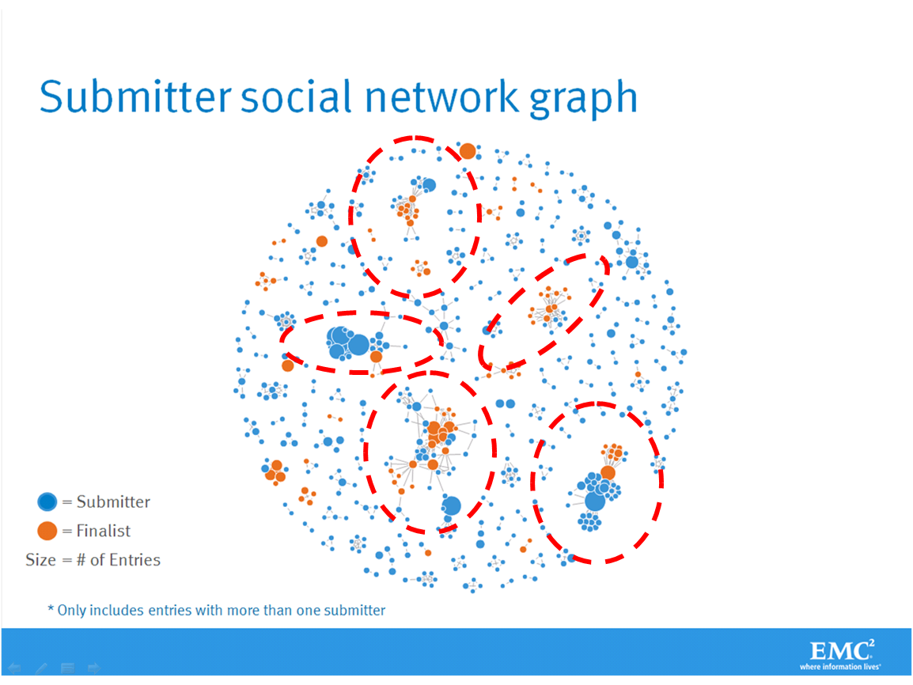

Phase 4: Model Building
- The GINA team employed several analytical methods. This included work by the data scientist using Natural Language Processing (NLP) techniques on the textual descriptions of the Innovation Roadmap ideas.
- Fig shows social graphs that portray the relationships between idea submitters within GINA.
  - Each color represents an innovator from a different country.
  - The large dots with red circles around them represent hubs. A hub represents a person with high connectivity and a high "betweenness" score.
- The team used Tableau software for data visualization and exploration and used the Pivotal Greenplum database as the main data repository and analytics engine.
Phase 5: Communicate Results
- This project was considered successful in identifying boundary spanners and hidden innovators.
- The GINA project promoted knowledge sharing related to innovation and researchers spanning multiple areas within the company and outside of it.
- GINA also enabled EMC to cultivate additional intellectual property that led to additional research topics and provided opportunities to forge relationships with universities for joint academic research in the fields of Data Science and Big Data.
Phase 6: Operationalization
- Deployment was not really discussed.
- Key findings:
  - Need more data in the future.
  - Some data were sensitive.
  - A parallel initiative needs to be created to improve basic BI activities.
  - A mechanism is needed to continually reevaluate the model after deployment.

Components of Analytic Plan - GINA Case Study
Components of Analytic Plan | GINA Case Study
Discovery Business Problem Framed | Tracking global knowledge growth, ensuring effective knowledge transfer, and quickly converting it into corporate assets. Executing on these three elements should accelerate innovation.
Initial Hypotheses | An increase in geographic knowledge transfer improves the speed of idea delivery.
Data | Five years of innovation idea submissions and history, six months of textual notes from global innovation and research activities.
Model Planning Analytic Technique | Social network analysis, social graphs, clustering, and regression analysis.
Result and Key Findings | 1. Identified hidden, high-value innovators and found ways to share their knowledge.  2. Informed investment decisions in university research projects.  3. Created tools to help submitters improve ideas with idea recommender systems.

CONCLUSION:
GINA (Global Innovation Network and Analysis) is a tool that provides insights and analysis to support innovation and technology development. It enables companies and organizations to stay up-to-date with the latest industry trends and technology advancements, allowing them to make informed decisions and stay competitive in their respective fields. The platform offers a range of features, including technology scouting, competitor analysis, and IP portfolio management, and can be customized to suit the needs of individual companies. Overall, GINA is a valuable resource for companies looking to innovate and stay ahead of the curve in their industries.

